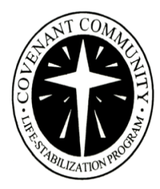

Career Services & Training
GOAL: To help job seekers prepare for, find and keep employment.
OJBECTIVE: Job seekers will learn job preparation, job readiness and job search skills to find gainful and meaningful employment. Also participate in training and educational interests.

JOB SUCCESS SKILLS – Four Simple Steps

PREPARE FOR THE JOB – USE JOB READY SKILLS
- Assess skills and abilities for jobs of interest.
- Resolve any barriers to employment
- Complete Certified Job Ready Course.
- Have a completed resume and cover letter.

LOOK FOR THE JOB – USE JOB SEEKING SKILLS
- Use Job Search Planning guide, tools and resources.
- Complete Weekly Job Search Plan.
- Complete Daily Job Search Tracking Form.

GET THE JOB – USE JOB FINDING SKILLS
- Be consistent in your weekly job search.
- Be patient and know the job you are seeking is seeking you.
- Complete the Job Placement Verification Form.

KEEP THE JOB! – USE JOB KEEPING SKILLS
- Focus on work/recovery balance. Address any concerns or issues.
- Use time management and organizational skills.
- Demonstrate appropriate work behavior and maintain professional boundaries.

